CONTENTS

Background 2
Description 2
Features 3
In Scope 5
Out of Scope 6
Dependencies 7
Limitations 7
Technology Stack 8
Technology Architecture 9
User Story 1 – User Registration & Login 10
User Story 2 – Complete Career Assessment 11
User Story 3 – Provide Educational Details 12
User Story 4 – Select Technical Skills 13
User Story 5 – Add Certifications 14
User Story 6 – Add Projects 15
User Story 7 – Select Career Interests 16
User Story 8 – Provide Internship / Experience 17
User Story 9 – View Career Details 17
User Story 10 – View Learning Roadmap 18

Background
The rapid evolution of technology has significantly increased the number of specialized career opportunities available to students and graduates. While educational institutions and online learning platforms provide access to technical knowledge and certifications, students often lack a structured mechanism to evaluate how their academic qualifications, technical skills, projects, certifications, interests, and practical experience align with specific career paths. Consequently, career decisions are frequently based on limited information, peer influence, or market trends rather than an objective assessment of individual capabilities.
CareerCompass is proposed to address this business need by providing a structured career recommendation platform that evaluates a student's profile and delivers personalized career guidance. The platform aims to improve career awareness, support informed decision-making, and help students identify the competencies required to achieve their professional goals.

Description
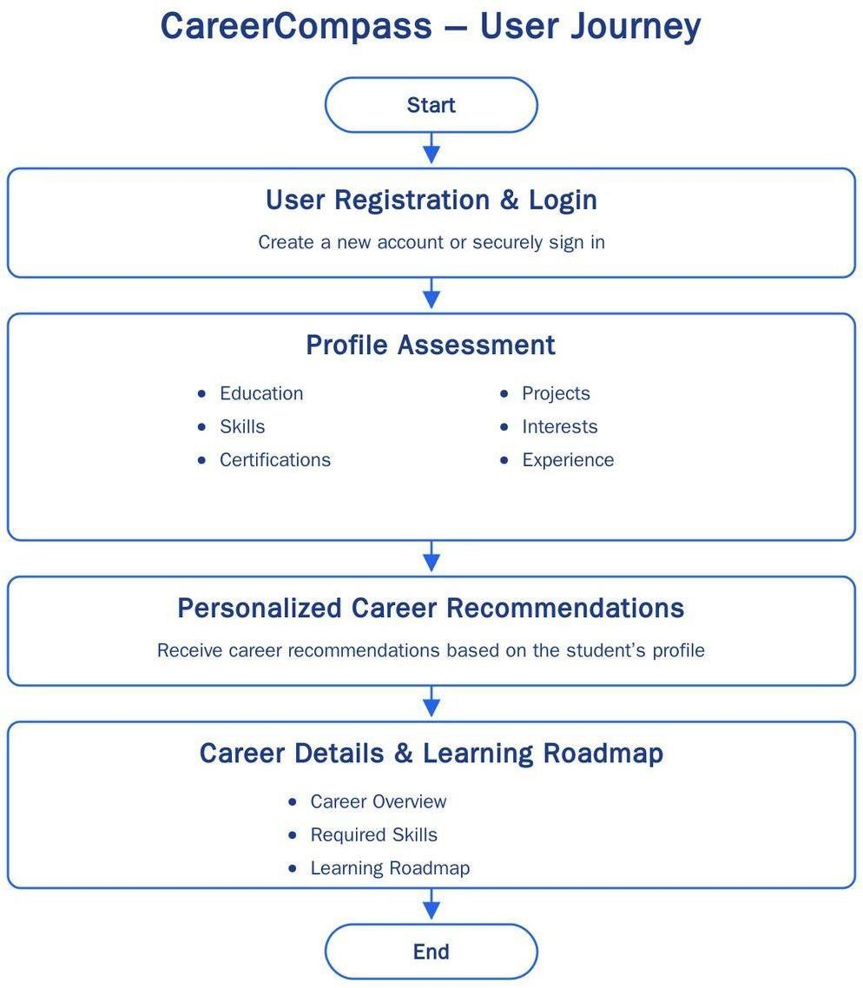
CareerCompass is a career guidance platform designed to help undergraduate students and recent graduates identify career paths that align with their academic background, technical skills, certifications, projects, interests, and practical experience. The platform enables students to create and manage their profiles, complete a structured career assessment, and receive personalized career recommendations based on their overall profile.
The application provides a centralized platform where students can explore recommended careers, understand the skills and qualifications required for each role, and follow a structured learning roadmap to achieve their career goals. By offering personalized career guidance and actionable learning paths, CareerCompass supports students in making informed career decisions and improving their industry readiness.

Features

Student Profile Assessment
Provides a guided multi-step assessment that collects the student's educational background, technical skills, certifications, projects, interests, and internship experience to build a comprehensive career profile.

Education Profile
Allows students to provide academic details such as qualification, branch/specialization, current year of study, and CGPA/percentage for profile completeness.

Skills Management
Enables students to select their technical and professional skills from predefined categories including Programming, Web Development, Artificial Intelligence, Data Analytics, Cloud & DevOps, Databases, Testing, Business Analysis, Mobile Development, and Soft Skills.

Certifications
Allows students to select or add professional certifications that strengthen their career profile and improve career matching.

Projects
Enables students to provide information about academic and personal projects completed across various technology domains.

Interests
Allows students to select the technology domains and career areas they are interested in pursuing, helping the recommendation engine understand their career preferences.

Internship Experience
Allows students to provide internship experience and other relevant technical activities that contribute to their practical exposure.

Career Recommendation Dashboard
Displays a ranked list of recommended career paths based on the student's overall profile match, enabling students to explore multiple career opportunities.

Career Details
Provides comprehensive information for each recommended career, including:
  - Career Overview
  - Roles & Responsibilities
  - Required Skills
  - Recommended Certifications
  - Suggested Projects
  - Suitable Internship Roles
  - Learning Roadmap

Learning Roadmap
Provides a structured learning path for each recommended career, guiding students from foundational concepts to advanced skills required to become industry-ready.

In Scope
The initial version (Version 1.0) of CareerCompass will focus on providing a structured, rule-based career recommendation platform for students. The following functionalities are included within the scope of this release:

Student Account Management
  - Student Registration and Login
  - Profile Editing and Updating
  - Persistent user profiles across multiple sessions

- Student Career Assessment
  - Multi-step assessment process to collect student profile information.
  - Capture educational details, skills, certifications, projects, interests, and internship experience.

- Student Profile
  - Create a comprehensive student profile using the assessment information.
  - Store profile details for generating career recommendations during the current assessment session.

- Skills & Experience Collection
  - Allow students to select technical skills from predefined technology categories.
  - Capture certifications, academic/personal projects, areas of interest, and internship experience.

- Career Recommendation Dashboard
  - Display a prioritized list of recommended career paths.
  - Present the most suitable career as the Top Recommendation followed by additional matching career options.

- Career Details
Provide detailed information for every recommended career, including:
  - Career Overview
  - Roles & Responsibilities
  - Required Skills
  - Recommended Certifications
  - Suggested Projects
  - Suitable Internship Roles
  - Learning Roadmap
  - Potential Employers

- Learning Roadmap
  - Provide a structured roadmap to help students progress from beginner-level concepts to industry-ready skills for the selected career.

- Explainable Recommendations
  - Display recommendation reasons to help students understand why a particular career has been suggested based on their profile.
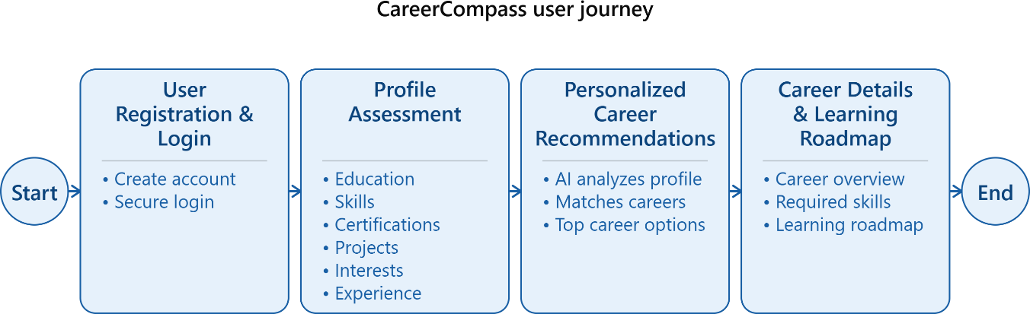

Out of Scope
The following functionalities are not included in Version 1.0 of CareerCompass. These features may be considered for future releases based on business requirements, user feedback, and product roadmap.

- Resume Processing
  - Resume Upload
  - Automatic Resume Parsing
  - Skill extraction from resumes

- External Platform Integrations
  - GitHub Integration for project and repository analysis
  - LinkedIn Profile Integration for importing professional details

- AI-Based Career Guidance
  - AI-powered Career Assistant / Chatbot for personalized guidance query resolution
  - Machine Learning-based recommendation engine
  - Natural language-based career recommendations

- Advanced Recommendation Features
  - Career Match Percentage / Compatibility Score
  - Recommendation history and comparison
  - Personalized skill gap analysis

- Career Exploration Enhancements
  - Search Career functionality
  - Bookmark or Save Career Paths
  - Personalized career tracking

- Mobile & Notification Features
  - Push notifications
  - Email notifications and reminders

Dependencies
The successful implementation and operation of CareerCompass depend on the following external resources and supporting components:

- Career Database
The recommendation engine depends on a predefined Career Database containing career profiles, required skills, certifications, projects, internship roles, learning roadmaps, and other career-related information. The quality and accuracy of recommendations depend on maintaining this data.

- Rule-Based Recommendation Logic
The recommendation process relies on predefined business rules and career matching criteria to evaluate student profiles and generate personalized career recommendations.

- Cloud Hosting Platform
The application requires a cloud hosting environment for deployment and accessibility to end
users.

- Version Control System
Git and GitHub are required for source code management, collaboration, version tracking, and project maintenance throughout the development lifecycle.

- Development Platform
The current prototype is developed using Lovable, which serves as the foundation for UI generation and rapid application prototyping during the initial development phase.

Limitations
The current version (Version 1.0) of CareerCompass has the following functional and technical limitations:

1.Rule-Based Recommendation Engine
The platform currently uses a predefined rule-based recommendation approach. Recommendations are generated based on configured business rules and predefined career profiles rather than Artificial Intelligence or Machine Learning models.

2.Exact Attribute Matching
The recommendation engine currently relies on exact matching of profile attributes with predefined career requirements. It does not perform semantic analysis, fuzzy matching, or intelligent interpretation of similar skills or technologies.
- Limited Recommendation Parameters
Although the application collects educational information such as qualification, branch, year of study, and CGPA for profile completeness, the current recommendation logic primarily evaluates:

  - Skills
  - Certifications
  - Projects
  - Interests
  - Internship Experience
Educational attributes are not currently considered in the recommendation process.

- No Personalized Learning Intelligence
The learning roadmap provided for each career is predefined and common for all users. It is not dynamically personalized based on the student's current skill level, strengths, or learning progress.
- No Resume Analysis
The platform does not currently support resume upload or automatic extraction of skills, certifications, projects, or experience from resumes.
- No External Platform Integration
The current version does not integrate with external platforms such as GitHub or LinkedIn to automatically retrieve or validate a student's technical profile.
- Limited Recommendation Explainability
Although the system provides basic reasons for recommending a career, it does not display
compatibility analysis, recommendation percentages, or comprehensive skill gap insights.

- Scalability Constraints
The current prototype is designed for demonstrating recommendation functionality and has not yet been optimized for large-scale production environments, concurrent users, or enterprise-level performance.

Technology Stack
The current prototype of CareerCompass has been developed using modern web technologies to enable rapid prototyping, responsive user experience, and maintainable application development. The technologies currently used or planned for Version 1 are as follows:

Component | Technology | Purpose
Application Platform | Lovable | Rapid application prototyping and UI generation
Frontend Framework | React.js | Building interactive and responsive user interfaces
Programming Language | TypeScript | Type-safe application development
Build Tool | Vite | Fast development server and application bundling
UI Framework | Tailwind CSS | Responsive UI design and Stylings
Routing | React Router | Navigation between application screens
Recommendation Engine | Rule-Based Recommendation Engine | Generates career recommendations using predefined business rules
Career Data Repository | Internal Career Database | Stores predefined career profiles, required skills, certifications, projects, internship roles, learning roadmaps, and career information
Client Storage | Browser Session Storage | Temporarily stores assessment data during the current user session
Version Control | Git | Source code version management
Repository Management | GitHub | Source code hosting, collaboration, and version tracking
Deployment Platform | To Be Finalized | Production deployment platform will be selected during implementation
Backend Services | To Be Finalized | Backend architecture will be designed during the development phase
Database | To Be Finalized | Production database technology will be finalized during implementation
Authentication | To Be Finalized | User authentication and authorization will be implemented in future development phases

Technology Architecture
The current prototype follows a client-side architecture, where:
  - The user completes a multi-step career assessment through the web interface.

  - Assessment information is temporarily stored during the active session.
  - The Rule-Based Recommendation Engine processes the student's profile by comparing it with predefined career profiles maintained in the internal Career Database.
The application prioritizes and displays the most relevant career recommendations along with detailed career guidance and learning roadmaps.
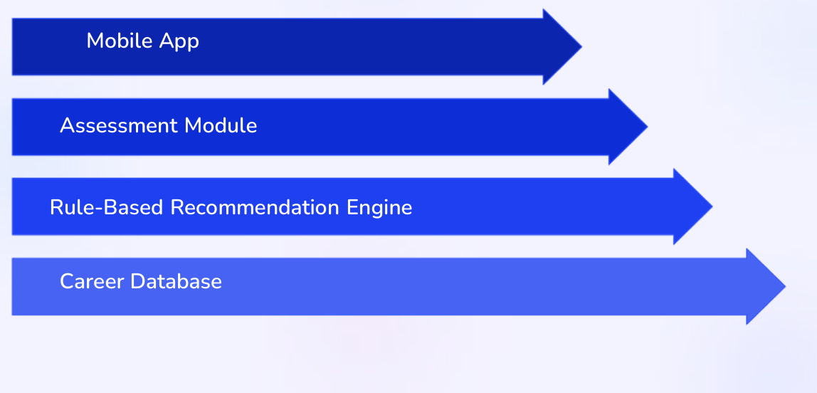

User Story 1
Headline - User Registration & Login
Description
As a student, I want to create an account and securely log in to CareerCompass so that I can access the career assessment, save my profile, and receive personalized career recommendations

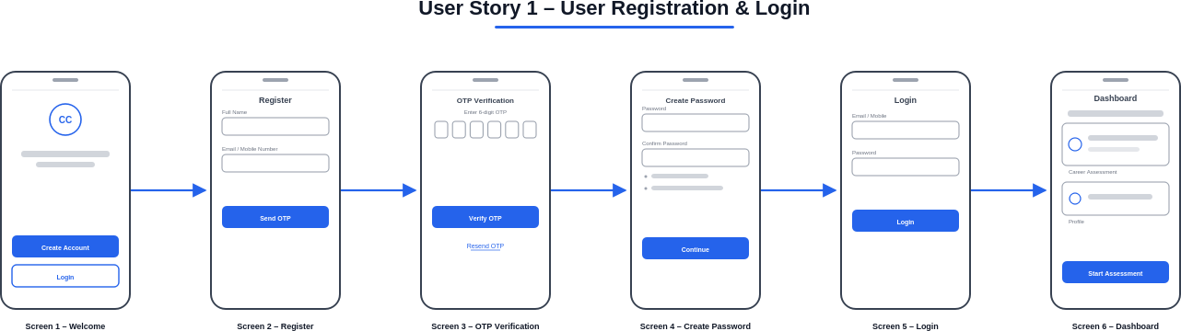
User Flow

Flow Description
The student registers and logs in to CareerCompass by completing the following steps:
- Open the CareerCompass application.
- Click Create Account.
- Enter Full Name and Email/Mobile Number.
- Click Send OTP.
- Enter the received OTP and verify the account.
- Create and confirm a password.
- Log in using the registered Email/Mobile Number and password.
- Access the CareerCompass Dashboard.
- Click Start Assessment to begin the career assessment process.

Acceptance Criteria
  - Student can create a new account using Email/Mobile Number.
  - OTP verification is required before account creation.
  - Student can create a secure password after successful OTP verification.
  - Student can log in using valid credentials.
  - Invalid credentials display an appropriate error message.
  - Successful login redirects the student to the Dashboard.
  - Student can start the career assessment from the Dashboard.

User Story 2
Headline - Complete Career Assessment
Description
As a student, I want to complete the career assessment by providing my education, skills, certifications, projects, interests, and internship experience so that CareerCompass can analyze my profile and recommend suitable career paths.

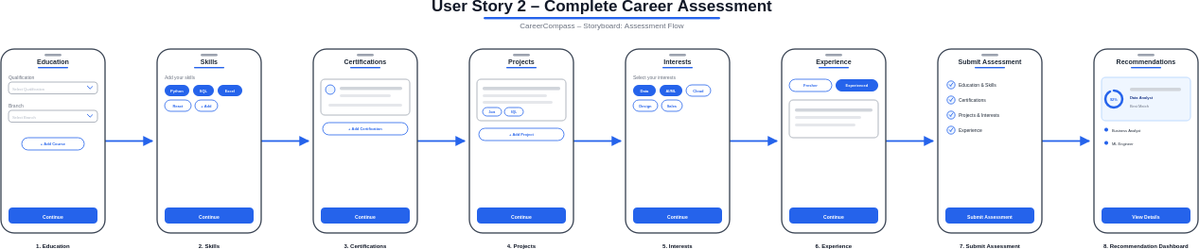
User Flow

Flow Description
The assessment process consists of the following steps:

- Provide Educational Details
- Select Technical Skills
- Add Certifications
- Add Projects
- Select Career Interests
- Provide Internship / Experience
- Submit Assessment
- View Career Recommendations

Acceptance Criteria
  - Student can complete all assessment sections sequentially.
  - Mandatory fields are validated before proceeding to the next step.
  - Assessment progress is displayed throughout the process.
  - Student can navigate between previous and next steps.
  - Assessment information is saved successfully.
  - Student can submit the completed assessment.
  - Personalized career recommendations are displayed after successful submission.

User Story 3
Headline - Provide Educational Details
Description
As a student, I want to enter my educational information so that CareerCompass can create my academic profile and provide personalized career recommendations.

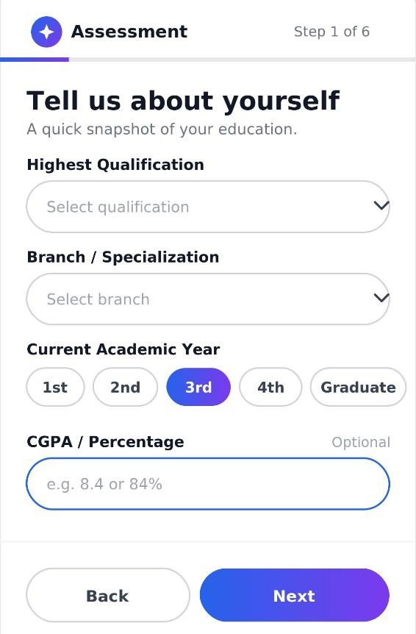
User Flow

Fig: Educational Details User Flow

Flow Description
The student provides academic information required for career assessment by completing the following details:
- Select the highest qualification.
- Select the branch or specialization.

- Choose the current academic year.
- Optionally enter CGPA or percentage.
- Click Next to proceed to the Technical Skills section.

Acceptance Criteria
  - Student can select the highest qualification from the available options.
  - Student can select the branch or specialization.
  - Student can choose the current academic year.
  - Student can optionally enter CGPA or percentage.
  - Mandatory educational details are validated before proceeding.
  - Student can proceed to the next assessment step after successful validation.

User Story 4
Headline - Select Technical Skills
Description
As a student, I want to select my technical and professional skills so that CareerCompass can evaluate my competencies and recommend suitable career paths.

User Flow
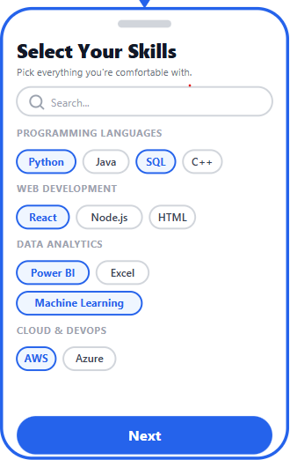

Fig: Technical Skills User Flow

Flow Description
The student selects technical and professional skills relevant to their expertise by completing the following steps:
- Browse skills organized into predefined categories.
- Search for specific skills using the search functionality.
- Select one or more technical and professional skills.
- Review the selected skills.
- Click Next to proceed to the Certifications section.

Acceptance Criteria
  - Skills are organized into predefined categories.
  - Student can search for specific skills.
  - Student can select multiple technical and professional skills.
  - Selected skills are saved successfully.
  - Student can proceed to the next assessment step after selecting the required skills.

User Story 5
Headline - Add Certifications
Description
As a student, I want to add my professional certifications so that CareerCompass can evaluate my qualifications and provide more accurate career recommendations.

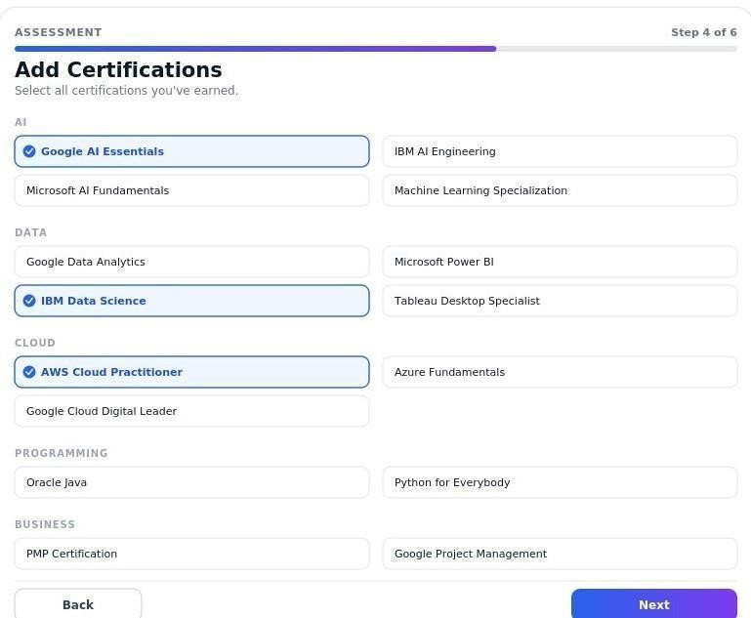
UserFlow

Fig: Certifications User Flow
Flow Description
The student adds professional certifications to strengthen their profile by completing the following steps:
- Browse certifications organized into predefined categories.
- Select one or more certifications.
- Review the selected certifications.
- Click Next to proceed to the Projects section.

Acceptance Criteria
  - Certifications are organized into predefined categories.
  - Student can select one or more certifications.
  - Multiple certification selections are supported.
  - Selected certifications are saved successfully.
  - Student can proceed to the next assessment step after selecting certifications.

User Story 6
Headline - Add Projects
Description

As a student, I want to add my academic and personal projects so that CareerCompass can evaluate my practical experience and provide more accurate career recommendations.

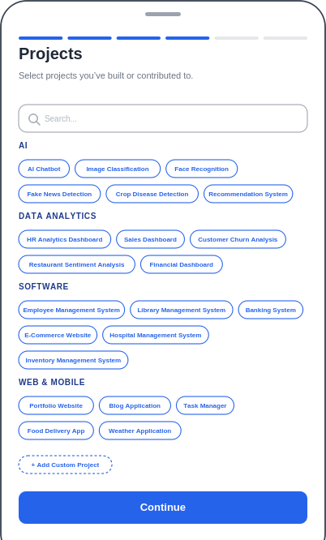
UserFlow

Fig: Add Projects User Flow

Flow Description
The student provides information about academic and personal projects by completing the following steps:
- Browse projects organized into predefined categories.
- Search for a specific project using the search functionality.
- Select one or more predefined projects.
- Add a custom project if it is not available in the predefined list.
- Review the selected projects.
- Click Next to proceed to the Career Interests section.

Acceptance Criteria
  - Student can browse projects organized into predefined categories.
  - Student can search for specific projects.
  - Student can select one or more predefined projects.
  - Student can add custom projects.
  - Multiple projects can be selected.
  - Project details are stored successfully.
  - Student can proceed to the next assessment step after adding project details.

User Story 7
Headline - Select Career Interests
Description

As a student, I want to select my career interests so that CareerCompass can recommend career paths that align with my preferences and aspirations.

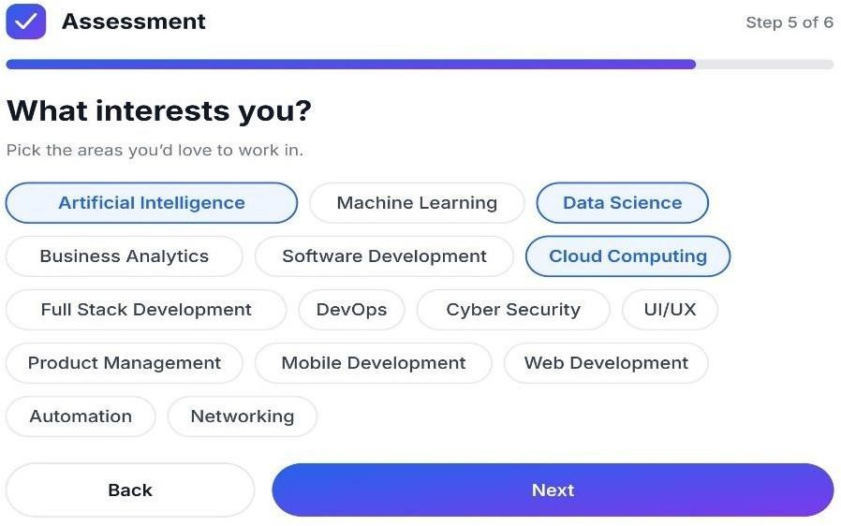
User Flow

Fig: Career Interests User Flow
Flow Description
The student selects areas of interest to help personalize career recommendations by completing the following steps:
- Browse the available career interest options.
- Select one or more areas of interest.
- Review the selected interests.
- Click Next to proceed to the Internship / Experience section.

Acceptance Criteria
  - Student can select one or more career interests.
  - Multiple career interest selections are supported.
  - Selected career interests are saved successfully.
  - Student can proceed to the next assessment step after selecting their interests.

User Story 8
Headline - Provide Internship / Experience
Description
As a student, I want to provide my internship and technical experience so that CareerCompass can evaluate my practical exposure and generate more relevant career recommendations.

UserFlow
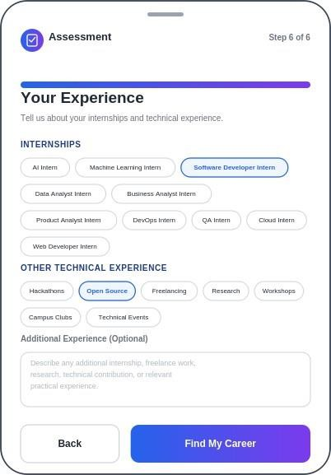

Fig: Internship / Experience User Flow
Flow Description
The student provides internship and technical experience details to enhance career recommendations by completing the following steps:
- Browse the available internship roles.
- Select one or more internship roles.
- Specify additional technical experience, if applicable.
- Review the selected internship roles and experience details.
- Click Find My Career to submit the assessment and generate personalized career recommendations.

Acceptance Criteria
  - Student can select one or more internship roles.
  - Student can specify additional technical experience.
  - Multiple internship roles and experiences can be added.
  - Internship and experience information is stored successfully.

User Story 9
Headline - View Career Details
Description
As a student, I want to view detailed information about a recommended career so that I can understand its roles, required skills, certifications, projects, internship opportunities, and potential employers before choosing my career path.

User Flow
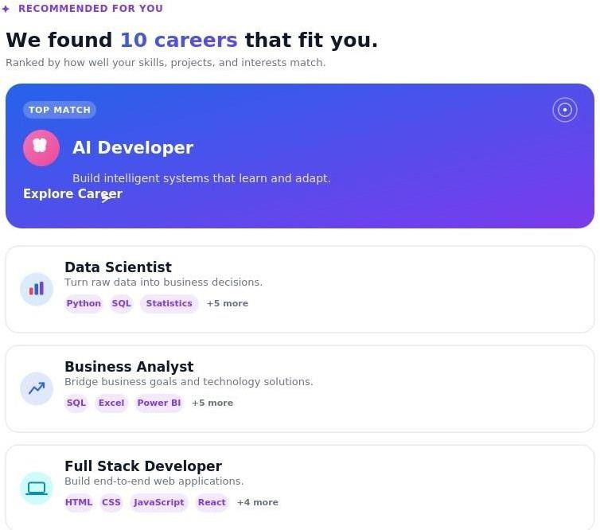

Fig: Career Details User Flow
Flow Description
The student explores detailed information about a selected career by completing the following steps:

- Select a recommended career from the Career Recommendation Dashboard.
- View the career overview.
- Review the roles and responsibilities.
- Explore the required technical skills.
- View recommended certifications.
- Review suggested academic and personal projects.
- Explore suitable internship roles.
- View potential employers.
- Click Learning Roadmap to access the structured learning path for the selected career.

Acceptance Criteria
  - Career overview is displayed successfully.
  - Roles and responsibilities are clearly presented.
  - Required technical skills are listed.
  - Recommended certifications are displayed.
  - Suggested academic and personal projects are displayed.
  - Suitable internship roles are displayed.
  - Potential employers are displayed.
  - Student can access the Learning Roadmap for the selected career.
  - Student can navigate back to the Career Recommendation Dashboard.

User Story 10
Headline - View Learning Roadmap
Description
As a student, I want to view a structured learning roadmap for my selected career so that I can systematically develop the required skills and become industry-ready.

User Flow

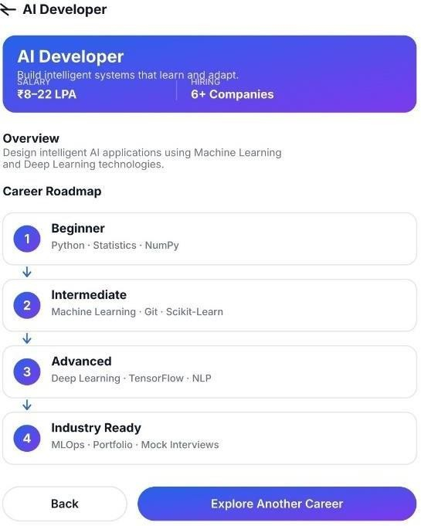
Fig: Learning Roadmap User
Flow Description
The student views the learning roadmap for the selected career by completing the following steps:
- Open the Learning Roadmap.
- View the Beginner learning stage.
- Progress through the Intermediate stage.
- Continue to the Advanced stage.
- Complete the Industry Ready stage.
- Navigate back to the Career Details page.

Acceptance Criteria
  - Learning roadmap is displayed in sequential stages.
  - Beginner, Intermediate, Advanced, and Industry Ready stages are clearly presented.
  - Each stage contains relevant learning objectives.
  - Learning roadmap is specific to the selected career.
  - Skills and technologies are organized according to each learning stage.

